MEMORANDUM

Date: | 31 January 2025
To: | Jefferson Lab Community
From: | Douglas Higinbotham  for the Nuclear Physics Experiment Scheduling (NPES) Committee
Subject: | FY25 Accelerator Schedule and Tentative FY26 Schedule

Accelerator Operations Schedule:

Attached is the updated accelerator operations schedule. It has also been posted at http://www.jlab.org/div_dept/physics_division/experiments/schedule.html. Access to the database format of the same schedule, as used by the beam accounting system, can be found at https://www.jlab.org/physics/experiments/schedule.
For the upcoming FY25 fiscal year, the lab has scheduled 25 weeks of physics operations along with 2 weeks dedicated to accelerator restoration. The tentative plan for FY26 again has 25 weeks of physics running along with 2 weeks of accelerator restoration. Both the FY25 and FY26 operations schedules are based on an anticipated funding profile and may be adjusted once the budgets have been finalized.
The table at the end of this document provides day-by-day details about the run conditions. A simplified version of the schedule is visualized in Figure 1. A full list of all 12 GeV experiments can be found at: https://www.jlab.org/physics/experiments.

Summary of Accomplishments During FY23 Run Period
During FY23 CEBAF delivered 30 weeks of beam to the physics program. This was three more weeks then originally planned, but the additional time allowed the running experiments to be completed so that the halls could be reconfigured for upcoming experiments and was greatly appreciated. In, Hall A, a measurement of the neutron form factor using recoil polarization transfer (E12-17-004) followed by an experiment to measure polarization transfer in wide-angle charged pion photoproduction (E12-20-005) were completed. Hall B solid and cryo-target experiments to understand color transparency and hadronization (Run Groups D & E) were run along with continuing a series of experiments to further our understanding of confinement and QCD (Run Group K). In, Hall C the new Neutral Particle Spectrometer (NPS) was installed and the first family of NPS experiments ran: DVCS (E12-13-010 and E12-13-007) along with E12-22-006 and E12-23-014. During this run period, Hall D worked on a major upgrade in preparation for the next generation of GlueX experiments and the run group JLab Eta Factory (JEF) experiments: experiments: E12-12-002 and E12-12-002A. And lastly, during a few days when none of the halls were running fifth pass, Hall D was able to take the beam and do some early detector commissioning and beam characterization measurements to ensure the hall would be ready for the FY25 run.

Summary of the Schedule Accelerator Maintenance and Upcoming Experiments:
During the 2024 scheduled accelerator maintenance (SAM), three refurbished cryomodules have been installed in the CEBAF accelerator: two in the north linac and one in the south linac. These three modules, 1L09, 1L22 and 2L05, along with planned plasma processing means that CEBAF linac energy can be increased from 1047 MeV/linac to 1060 MeV/linac while keeping the expected trip rate low. With this energy gradient along with injector energy, CEBAF will be able to deliver up to 10.7 GeV to Halls A,B,&C and nearly 11.8 GeV to Hall D. This will be an important milestone for CEBAF, as the machine will now be delivering stable beam above the minimum energy required for the upcoming MOLLER experiment. The SAM was longer than expected due to a laboratory decision to address Lock-Out Tag-Out deficiencies found during a proactive peer review.

For the FY25 run period, Hall A will be completing the Super BigBite form factor program with the high impact experiment (E12-07-109) to measure the proton electric form factor at high Q², along with a more recently approved (E12-24-10) high precision measurement at lower Q². Once these experiments are complete, the Super BigBite equipment will be removed, and the installation of the MOLLER experiment will begin. In Hall B, the ALERT Run Group L experiments will run, followed by the short-range correlation (E12-23-013) experiment which also makes use of the ALERT detector. In Hall C, the large acceptance device (LAD) experiment will run, followed by (E12-06-104) that will measure σ_{L}/σ_{T} in Semi-Inclusive Deep-Inelastic Scattering. Hall D will run the GlueX-II and JEF experiments and, for the first time, be requesting longitudinal polarization to carry out the recently approved run group addition (E12-12-002A).

The tentative plan for FY26 is to continue the Hall A MOLLER installation and in Hall B to run the Prad-II and X17 experiments. In Hall C, the plan is to run the Color Transparency (E12-06-107), Nuclear R (E12-14-002), N-Delta (E12-22-001) and Polarizabilities (E12-23-001) experiments and in Hall D to complete the GlueX-II/JEF experiment. An interesting feature of this run period is that once GlueX-II/JEF are complete, the program requires reducing the machine energy from 1060 MeV/linac to around 700 MeV/pass to get to the special kinematics needed for the planned Hall B and C experiments. This lower energy will not be available during the year of MOLLER running.

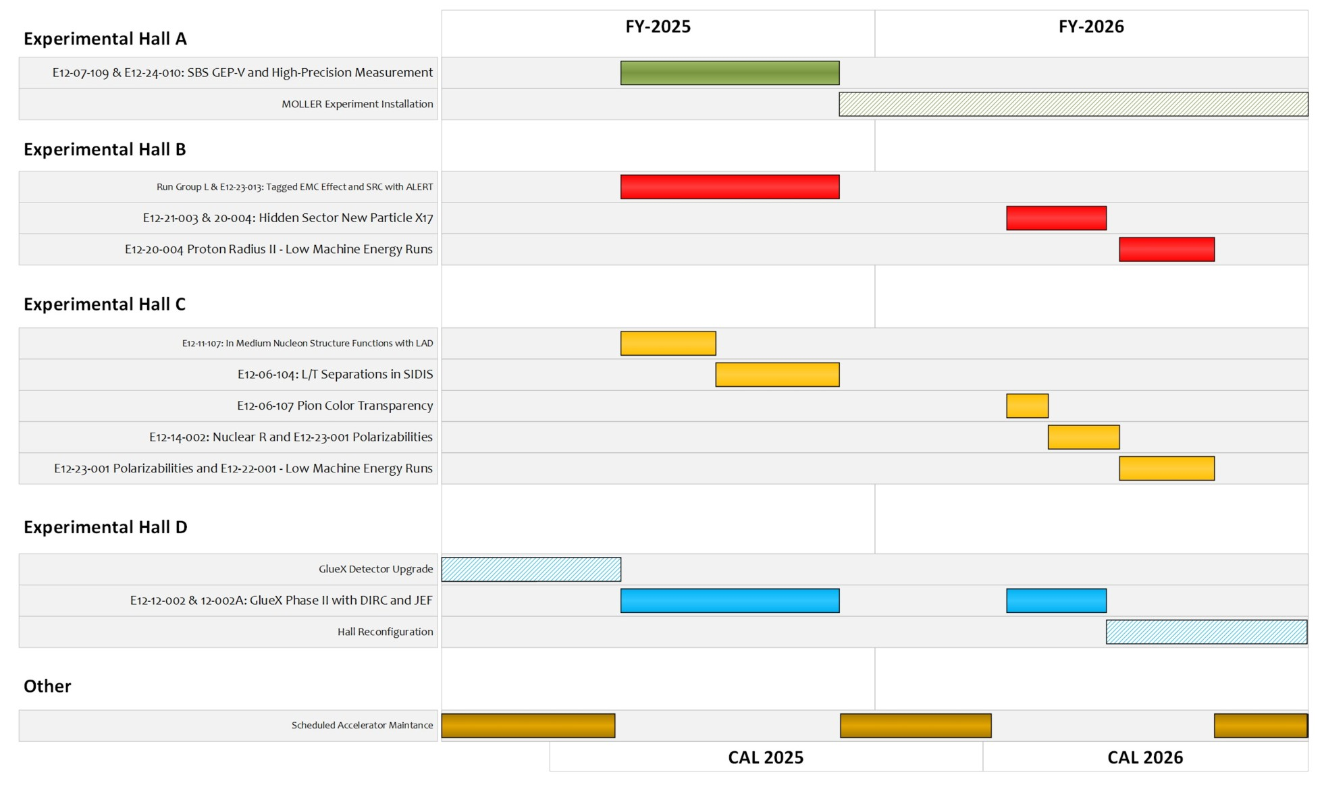
Figure 1 - Experiment schedule Gantt chart. Experiments that have completed their ERR and are scheduled for the upcoming year are considered firm while all other experiments shown which have not completed their ERR should only be considered as tentative.

Detailed Scheduling Information

When making the run schedule, each Program Advisory Committee (PAC) approved day is mapped onto two calendar run days. This factor of two accounts for projected accelerator and Hall inefficiencies due to system failures - not experiment overhead. It also accounts for 12 hours of beam-off time for maintenance and up to 12 hours a week for scheduled beam studies. An additional 8 hours a week is allocated for beam tuning to support program changes or to address beam quality issues. The remaining 136 hours a week is scheduled for physics.
The schedule itself is developed by the Jefferson Lab Nuclear Physics Experiment Scheduling (NPES) committee. The current NPES committee members are: Eugene Chudakov, David Dean, Joe Grames, Douglas Higinbotham (Co-Chair), Mark Jones, Cynthia Keppel, Eduard Pozdeyev (Co-Chair), Patrizia Rossi, and Mike Spata, with valuable input provided from both accelerator and physics division support groups as well as facilities and engineering teams with special thanks to Jay Benesch and Jonathan Creel for their invaluable input. After final review by the NPES committee, the schedule goes to the Jefferson Lab Director Kim Sawyer for final approval.

Constraints and Special Experiment Requirements
Each experimental hall has an Accelerator-Physicist Experimental Liaison (APEL) that serves to aid the Nuclear Physicists in beam related issues during all phases of an experiment: proposals, commissioning, operating and analysis. The APELs, with input from the Halls, injector, and diagnostics staff have developed a beam parameter table for the 12 GeV era (JLAB-TN-18-022). Experiments requiring more stringent beam parameters should consult the APEL of the Hall in question: Yves Roblin (Hall A), Mike Tiefenback (Hall B), Jay Benesch (Hall C) and Edith Nissen (Hall D). Some of the key machine constraints are as follows:
- Total power limited to 1.1 MW with the Hall A and C dumps limited to 0.9 MW
- 4-hall operations require at least one of the original Halls (ABC) to receive 5th pass beam.
  - It is strongly preferred that the original Halls be A or C. Coupling B-D, while possible, places additional constraint on B & D currents.
  - Any of the original Halls receiving 5th pass beam concurrently with Hall-D will receive beam with a 249.5 MHz repetition rate.
  - 499 MHz repetition rate is available when a Hall is receiving pass 1-4 beam.
- Hall-D must be at 249.5 MHz repetition rate whenever an original hall is simultaneously receiving 5th pass beam.
- Hall-D can only receive 499 MHz beam when only two of the original Halls are receiving beam on the lower passes (1-4). In this case, only three Halls are in operation.
- On the schedule, daily status changes take place at the end of the owl shift (~ 7 AM) unless otherwise indicated.
- Operating one or more of Halls A, B and C at five passes together with Hall D at 5.5 passes requires a polarized gun laser frequency of 249.5 MHz. A laser frequency of 499 MHz can be used otherwise. For the same average beam current, the charge per micro-bunch when operating the laser at 249.5 MHz will be twice that of 499 MHz. For each hall, the energy, current, polarization column now also includes the laser frequency.

Daily Accelerator Schedule
The operation of more than one Hall at Jefferson Lab substantially complicates the interaction between the experiment and accelerator operations groups. It is in the interests of the entire physics community that the laboratory be as productive as possible. Good communication between the halls and accelerator is essential. Thus, the Run Coordinators for all experiments either receiving beam or scheduled to receive beam in the coming days should meet with the Program Deputy, either in person or via zoom, at 7:45am in the MCC on weekdays and at the Program Deputy’s discretion on weekends: typically, around 9:00am via zoom.
While zoom is very convenient and can often be used quite effectively, Run Coordinators are strongly encouraged to attend the weekday 7:45am and 8am meetings in person. When an experimental hall is having beam issues or making special requests, Run Coordinators are required to attend morning meetings in person. This helps not only with communicating the needs of the experiment but also allows for in-depth, multi-person conversations that are not easily done remotely.

Run Coordinators for all operating halls should do their best to respond flexibly to the needs of the experiments running in other halls and it is best when the Run Coordinators coordinate actions (such as a half-wave plate change) along themselves; though even these coordinated actions should be discussed at the daily meetings to ensure everyone is aware of upcoming changes. Also, Halls should minimize non-emergency requests for beam delivery modifications during accelerator shift changes, nominally 7:30-8:30am, 3:30-4:30pm, and 11:30pm-12:30am.
Best effort will be made to deliver the beam conditions identified in the schedule, but when those parameters cannot be achieved or when Run Coordinators cannot agree on parameters effecting multiple halls, the Director of Physics Operations (Douglas Higinbotham) in close collaboration with the Director of Accelerator Operations (Eduard Pozdeyev) will communicate the best course of action to the Program Deputy.

To provide some guidance to operations and to add some order to the process of resolving short-term difficulties running multiple Halls, we have assigned a priority Hall for each day beam delivery has been scheduled. This should simply be thought of as a primus inter pares, Latin for “first among equals”. As always, accelerator division will do their best to deliver the required beam to all halls; but when that is not possible and assuming no special guidance from the Program Deputy has been given, operations will use the priority hall designation to determine which hall takes precedence in delivering the beam.

Initial Tune-up of New Beams:
Normally 1.5 shifts (12 hours) is set aside for tune-up whenever a new beam setup has been requested. For unusual beam setups more time may be scheduled explicitly for tuning at the discretion of the scheduling committee. It is understood that beam tune-ups shall always be done in the order that the accelerator operations group believes will minimize the total time needed to tune all scheduled beams (i.e., the "priority Hall" beam is not necessarily tuned first).

Maintenance/Beam Studies.
As noted earlier, Accelerator Division may request up to twenty-four hours per week for maintenance and beam studies, including recovery: 12h beam studies + 12h general and SRF maintenance. This total time should include any restoration time needed to return to nominal operations. The Run Coordinators will be consulted in deciding how this time is scheduled, e.g. several shorter or a few longer blocks of time. During the upcoming run period, accelerator may switch to a bi-weekly maintenance/beam studies period making use of larger single blocks of time but still averaging twenty-four hours per week.

With the machine running at 499 MHz, it is only possible to send the beam to three halls and only possible to send to Hall D with no other hall at 5th pass.
SAM’s were previously referred to as the SAD or Scheduled Accelerator Down.

